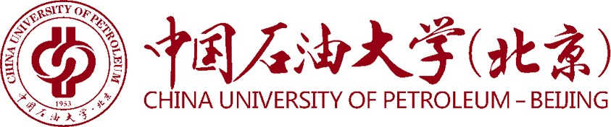

**Certificate of Registration**

December 31st, 2020

This is to certify that Mr./Ms. ZHANG San (Student ID No. 2017010001), born on Dec. 1st, 1995, has been enrolled at China University of Petroleum-Beijing at Karamay and registered as a four-year full-time undergraduate student, majoring in Petroleum Engineering in the School of Petroleum , since September 2017. He/She is now a junior (freshman, sophomore, junior, senior) student at this university.

If he/she completes the study as required by his/her program, he/she will be awarded the Diploma and the Bachelor's Degree in Engineering in June 2021.

Academic Affairs Office

China University of Petroleum-Beijing at Karamay

Add:355 Anding Road,Karamay,Xinjiang,P.R.China Zip:834000

Tel:+86 990 6633039

Email:my@cupk.edu.cn

